A stroll in the woods

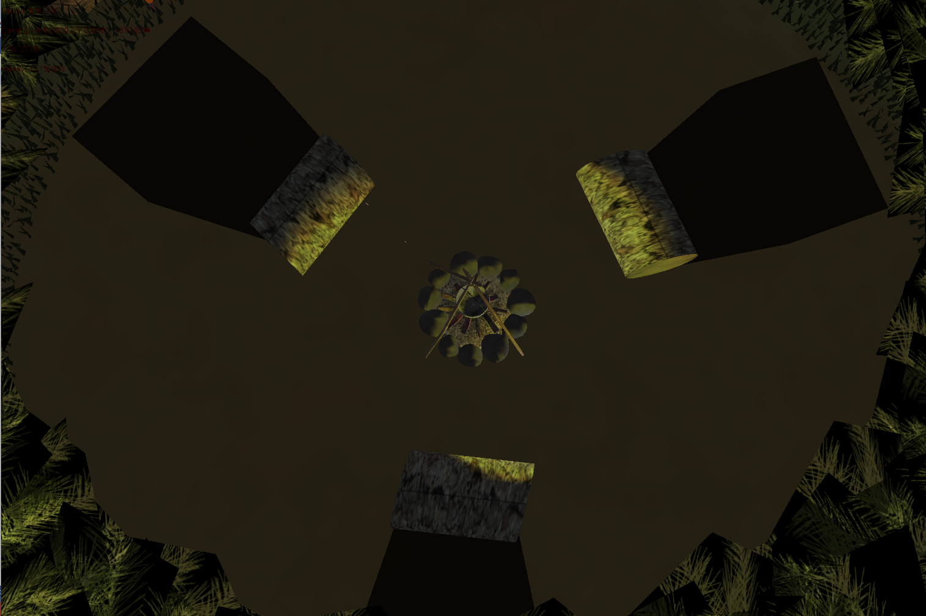

Jamie Haddow

CMP203

0705082

**Overview**

For the given task, I created a “mostly” calming forest with a few of my favourite characters for games/anime. This open area gave me the space to show off the different weekly techniques, and present the opportunity to show my own originality.

This application was created in C++ using OpenGL2.0(Fixed pipeline) with which a framework was provided by the lecturer. I used a single external library, irrKlang for audio (“<https://www.ambiera.com/irrklang/>”)

**Controls**

**Camera 1:**

W,A,S,D for general camera movement. Z and X for vertical movement.

Mouse movement controls the Pitch and Yaw

**Camera 2 and 3**

No specific controls as they are fixed positions

**User Control:**

- and + keys turn wireframe on and off.

M,N,B,V to control the arm above the firepit

K turns on a transparent stencilled version of the world above the scene and a great cost to the fps of the program. Please use with caution!

**Requirements**

Following the project brief, the requirements are:

* Geometry
* Lighting
* Camera and Interaction
* Hierarchical Modeling
* Advance features
* A wire frame mode
* OOP

I will now go into more detail, each of these requirements and how I feel I met the needs of each

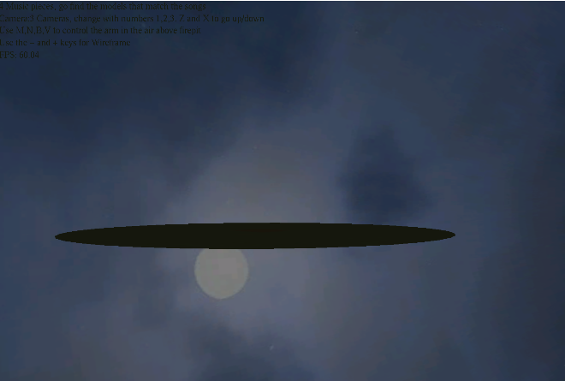**Geometry**

SkyBox

Using a sphere with a camera

Placed inside using depth test

Created an endless scene.

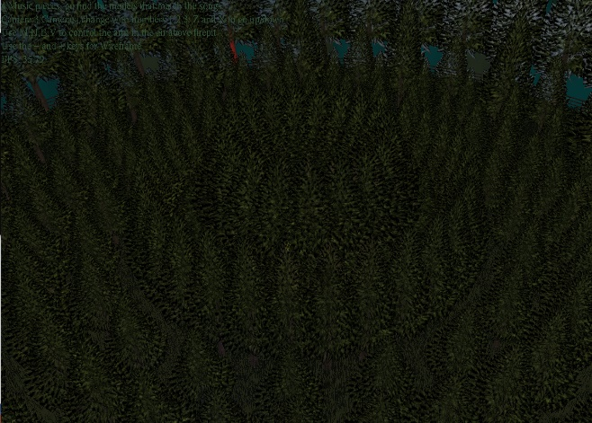

Hand crafted scenery

By using models found online

I created my own forest using

Loops and rotations.

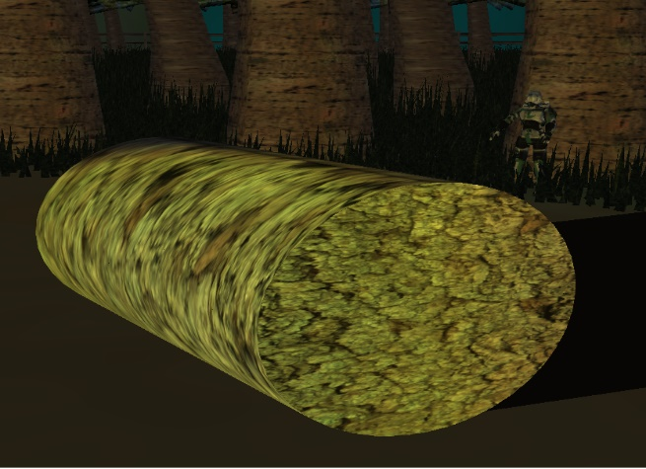

Procedural generation

I generated a disc to create the floor.

I then created a cylinder and used 2

of the discs I created to make a log

shape used in the scene.

**Lighting**

This project contains 7 active lights and 1 “world light”. By world light, this is simply a light with an ambient value attached to it to give a general brightness to the scene.

2 point lights were used for the firelight to give a warm glow in the open area in the center of the scene and with the zombie wandering arounds the scene in the trees

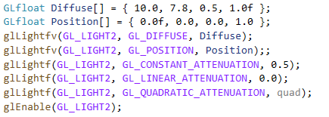

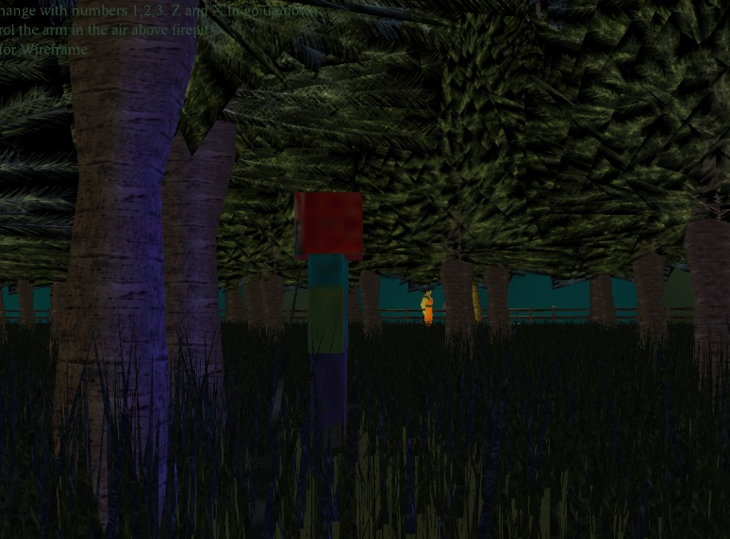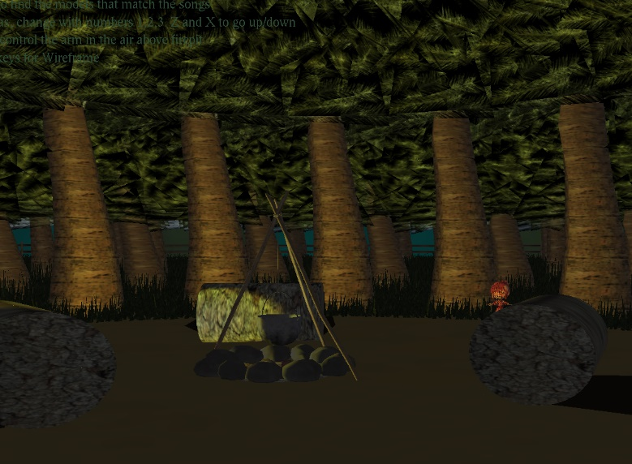

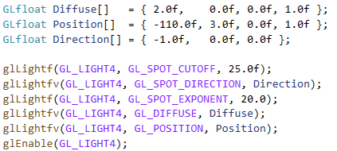4 Spot lights were used to highlight the models placed in 4 corners of the scene.

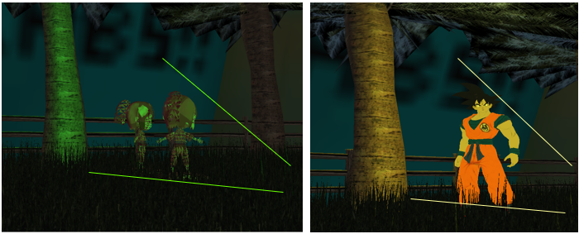

**Camera**

This project contains 3 cameras. Camera 1 is free roaming. Camera 2 is a static location above the scene giving the user an overall view of the forest. Camera 3 is a static camera that rotates around the Y axis following the zombie that wanders in the forest.

I was hoping to use Camera 3 as a 3rd person follow on the zombie, however I was unable to retrieve the objects positions using the worldMatrix so I had to resort to a much simpler solution of setting the camera to a set position just above the origin on the Y axis and then have the camera rotate on the yaw axis using the same variable that the zombie uses to simulate it following the object

Below is the code I used to initialise the camera positions for use and how I setup camera 3 to follow the zombie with a few images of the different cameras in use.





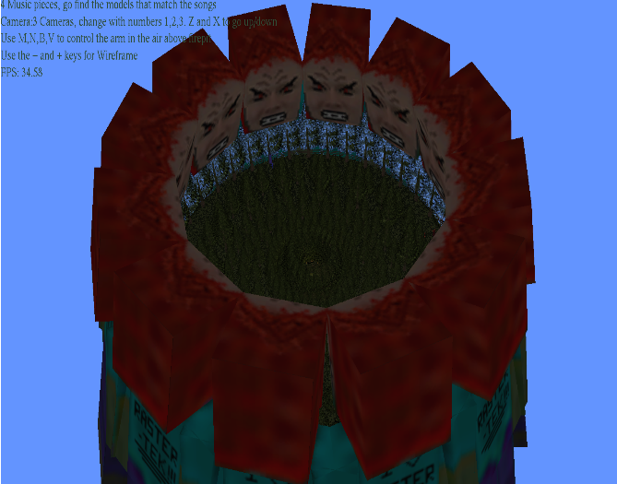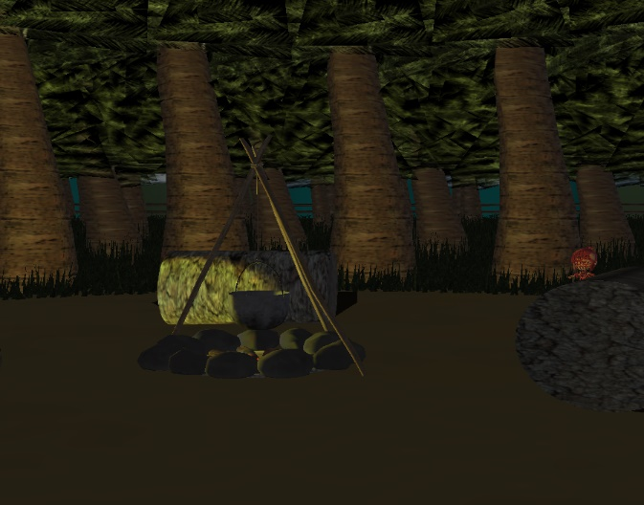

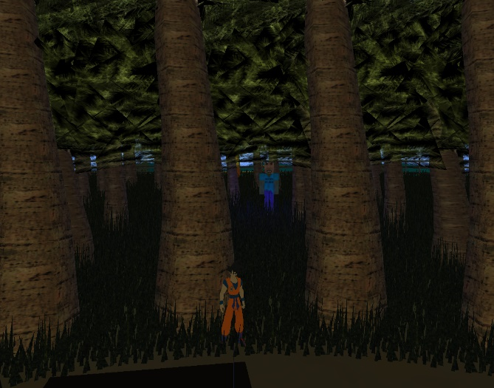

**Hierarchical modelling**

I used matrix stacks throughout the project. Here are a few examples.

1. 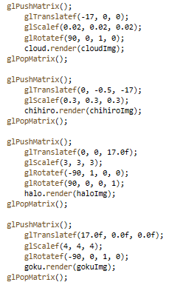Creating my arm object from the openGL red book **2.)**
2. Setting my models locations
3. Stencil buffering my objects

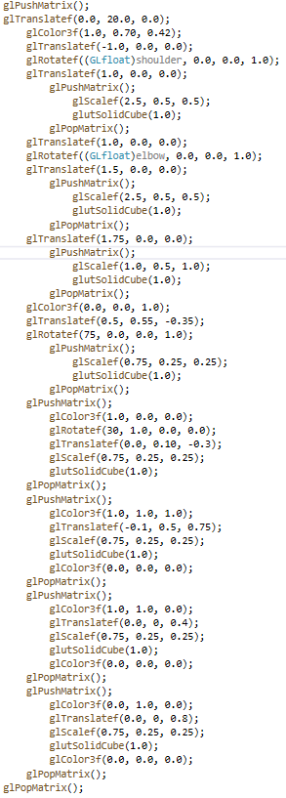**1.)**

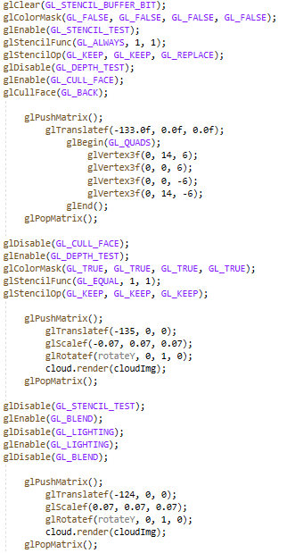 **3.)**

**Advance features**

**Stencil buffer usage**

In my scene I used stencil buffering on a number of my objects. You can see this used on the 4 models around the edge of the scene. If you also look up and press K you can also see a silly attempt at stencilling the entire world at a huge fps cost.

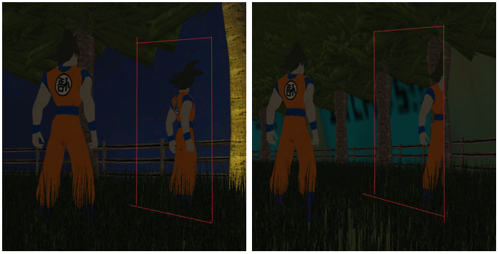

**Shadow usage**

I used the second approach from the lecture, planar shadows for my scene. I was going to do the same for the front row of trees however, due to the grass it would be a waste of resources

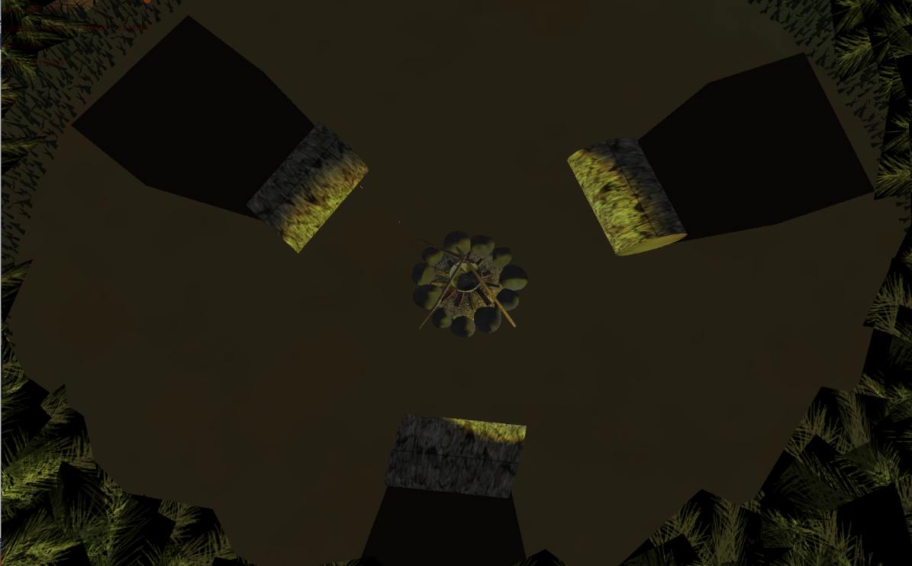

**Object Oriented**

I did my best to reduce the number of function calls in render and the following image shows my thought process.

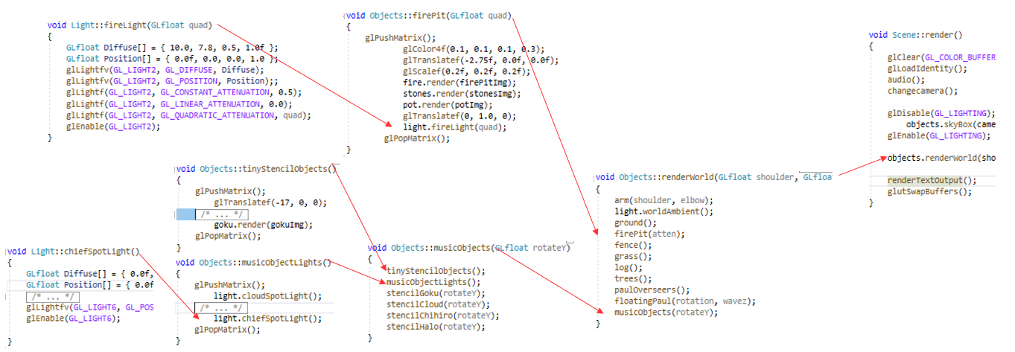

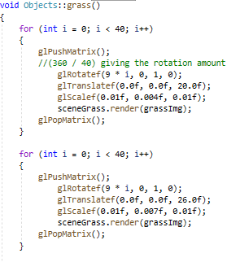**Code examples**

Here are a few extra examples of my code

Below: my floor generation

Right: my grass functions

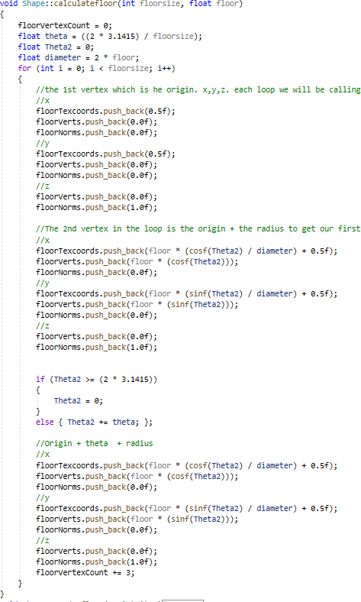

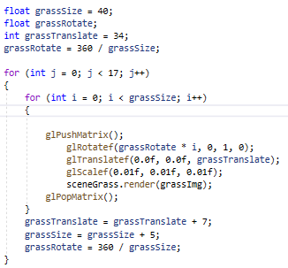

**References**

The websites I used for 3d models were:

<https://www.turbosquid.com/> <https://www.models-resource.com/> <https://free3d.com/>

The music I used in my project I found on YouTube, downloaded in MP3 format and then converted to wav using audacity. The songs I used were:

Halo theme song - <https://www.youtube.com/watch?v=0jXTBAGv9ZQ>

Dragonball Z 'Chala Hey chala' - <https://www.youtube.com/watch?v=pYnLO7MVKno>

Spirited away 'Inochi No Namae' - <https://www.youtube.com/watch?v=ImPM5IDIYPs>

FF7 Aeriths Theme - <https://www.youtube.com/watch?v=fIqKWLkm2-g>

For my skybox, I used a sphere from 'song Ho Ahn' - <http://www.songho.ca/opengl/>